Name: Melissa Hunfalvay

**You will turn in this sheet.** Crop off the previous instruction pages from this document. Fill out and turn in these pages.

**Part 3 Questions**: The following questions pertain to Part 3, the Property Database:

1. Paste a screenshot of your Property EER/ERD below. (It’s OK to adjust the spacing in the document if you need more room.)

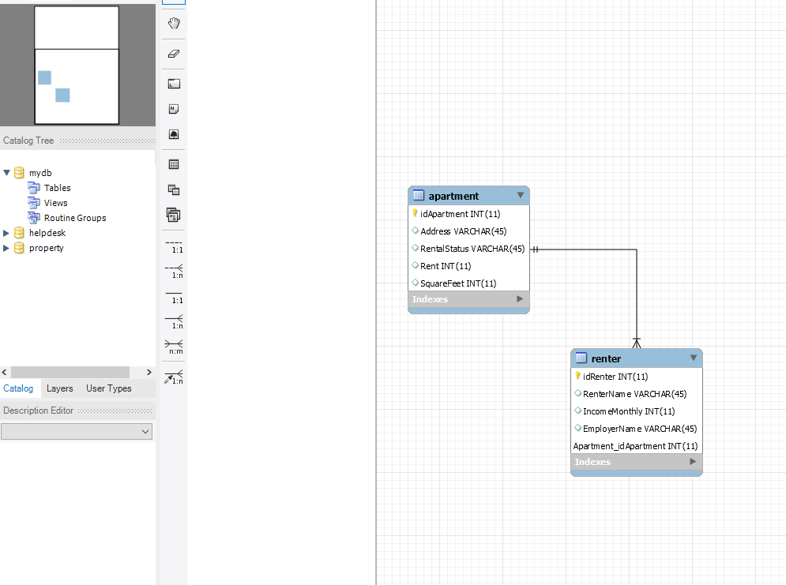

Answer the following questions by placing an “X” next to your answer:

1. How many tables are in this database:

[ ] One table, called property

[X] Two tables, called apartment and renter

[ ] Three tables, called property, apartment, and renter

[ ] Cannot tell from available information

1. The primary key of the apartment table is called

[X] idApartment

[ ] idApartment INT

[ ] Apartment_idApartment

[ ] Apartment_idApartment INT

1. Which sentence(s) best describe relationships depicted in this diagram? Answer based on what the diagram denotes, not based on what you think the ‘real world’ “should” have. Check all that apply.

[X] Each apartment must have one or more renters

[X] Each renter must rent one and only one apartment

[ ] Each apartment may have one or more renters

[ ] Each renter may have one and only one apartment

[ ] Each apartment must have one and only one renter

[ ] Each renter may rent one or more apartments

**Part 4 Questions**: The following question pertains to Part 4, the Animals Database.

Include a screenshot of your Animals EER Diagram here. Make sure everything important is visible – you may need to move boxes or increase their size so all the words show.

